### **Overview: Dockerfiles and Kubernetes**

1. **Dockerfile**:
   * A Dockerfile is a script containing instructions to build a Docker image. It includes commands to set up the environment, install dependencies, copy application code, and specify the command to run the application.
   * We use a Dockerfile to build a Docker image using the docker build command.
2. **Docker Image**:
   * After the Docker image is built from the Dockerfile, it is pushed to a container registry **Docker HUB**.
   * The Docker image contains everything needed to run the application, including the code, runtime, libraries, and environment variables.
3. **Kubernetes Deployment**:
   * In a Kubernetes cluster, we don't directly use the Dockerfile. Instead, you refer to the pre-built Docker image in your Kubernetes manifest deployment-YAML files.
   * Kubernetes pulls the Docker image from the specified container registry and runs it inside a pod.

### **Workflow: Dockerfile to Kubernetes Deployment**

1. **Build the Docker Image**:

First, we create a Dockerfile for our application (as we did with app1 and app2).

Then, we build the Docker image using:

docker build -t shubh301/app1:latest -f Dockerfile.app1 .

docker build -t shubh301/app2:latest -f Dockerfile.app2 .

1. **Push the Docker Image to a Registry**:

After building the image, you push it to a container registry:  
docker push shubh301/app1:latest

docker push shubh301/app2:latest

**Solution:**

**1.git init and git clone**

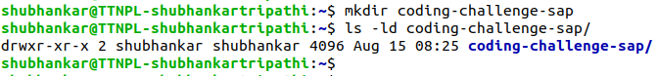

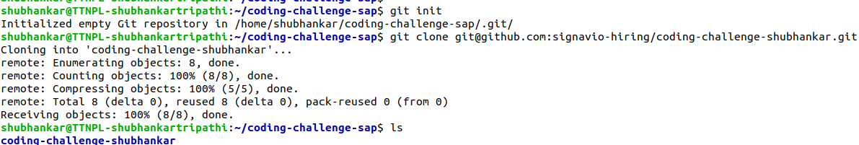

**2. After writing the app1 and app2, docker files and deployment.yaml**

**3. Checking if app is working on local**

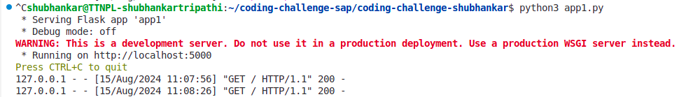

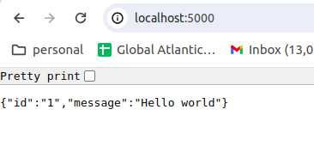

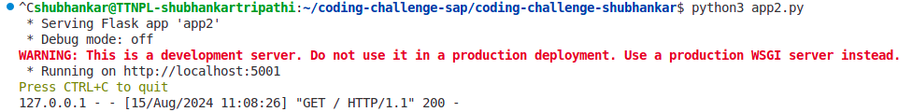

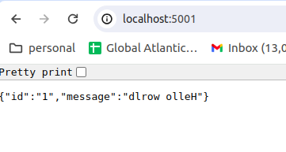  
**4.docker login and Building docker image and pushing on docker hub**

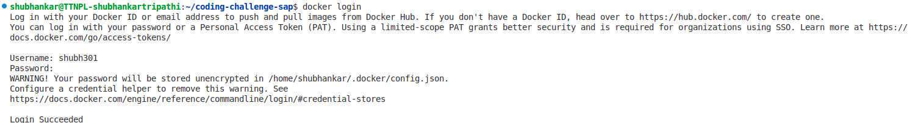

>docker build -t shubh301/app1:latest -f Dockerfile.app1 .

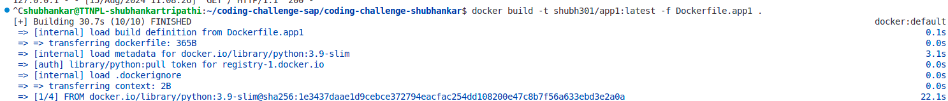

>docker push shubh301/app1:latest

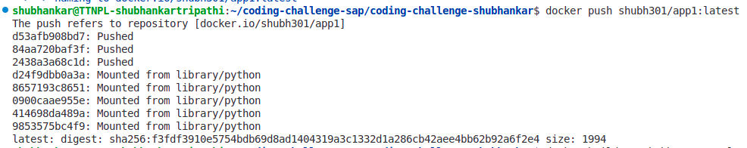

>docker build -t shubh301/app2:latest -f Dockerfile.app2 .

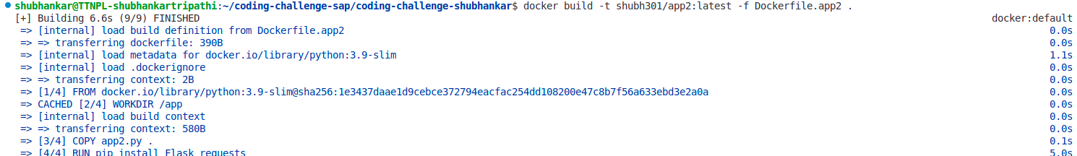

>docker push shubh301/app2:latest

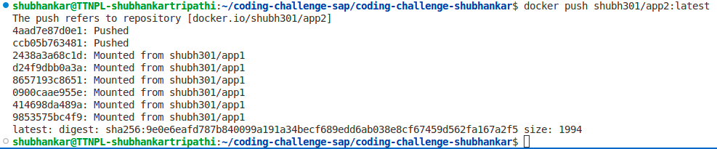

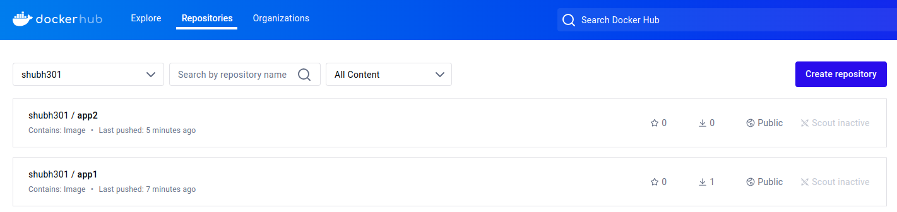

Docker images are in public repo, so no need to use docker creds in the deployment file.

**5.kubernetes cluster and namespace**



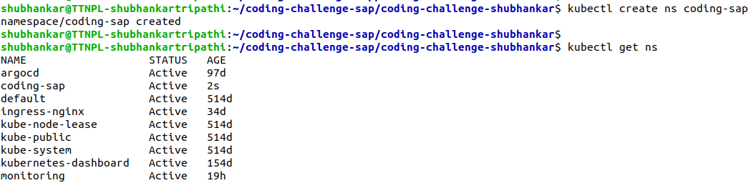

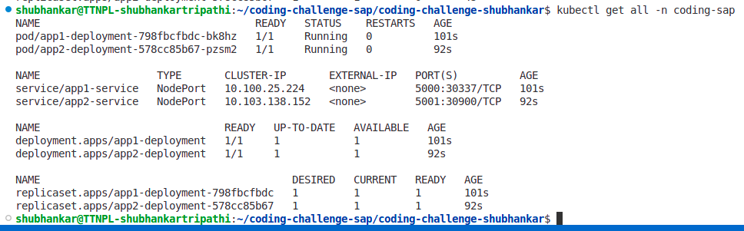

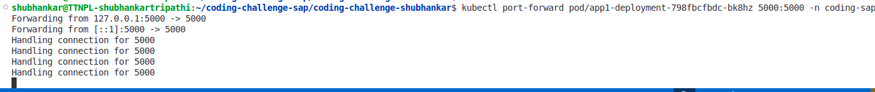

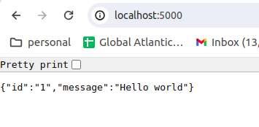

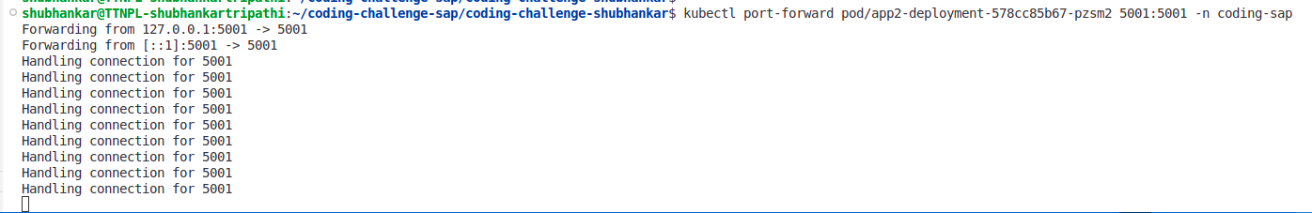

**6. Enabling NodePort service and using cluster IP without using port forwarding**

